LUNA COUNTY RANCHETTE OWNERS ASSOCIATION (LCROA)

HISTORY

Origin: In 1972 a few hardy folks, newly retired, made the mistake of falling for the “Luna County ranchette land scam”. They joined together as LCROA and built a clubhouse...over 500 members by the 1980s. They sponsored annual fiddle contests plus operated a thrift store. However, within a few years the club became an adjunct senior center. By 2012 the 100 or so remaining members were ready to throw in the towel.
What was the land scam? Over 60 years ago Luna County allowed a bad actor, Carter Kirk, to create 126 sub-standard subdivisions made up of over 77,000 half-acre lots. That many half-acre lots all developed with housing would have outstripped water resources and be damaged by flood plains and other environmental issues. LCROA calls these subdivisions antiquated and says enough is enough. We need some way to stop the perpetual resale of these lots to out-of-town buyers who have no idea about living in a desert. Ranchers understand there’s a limit to how many cows can graze in desert rangeland so that next season the rangeland will still be good. The same principles should be applied to housing people in the Chihuahua Desert.

Transition: A small group of "younger" retirees arrived on the scene. They tried reviving dinners and renting out the clubhouse, but volunteers were in short supply and the senior center role was no longer needed. In 2015 the clubhouse was sold on a contract for deed. The thrift store continued until 2018 but with too few volunteers, it was donated to Deming Silver Linings. The contract for deed for the clubhouse sale was paid off in 2020 and the Board of directors voted to give $110,000 to the Grant County Community Foundation to be awarded to nonprofit activities in Luna County. The Board then began looking at what if any role LCROA might provide to the ranchette subdivisions of Luna County.

Today: LCROA has envisioned a community role to help correct the substandard ranchette subdivision land scam.

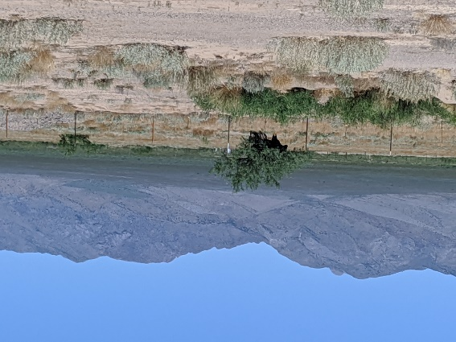

VISION FOR THE FUTURE

The Board of Directors adopted the following goals in 2022 to be a more active participant in re-making the ranchette subdivisions into viable areas of Luna County’s future.
1. Study the facts. Analyze ground water, current road access, electric power lines, topography, soils, flooding history and more, overlayed with ranchette ownership records to identify subdivisions best situated for housing, solar/wind farms, open space, or other potential uses.
2. Host community forums to educate and encourage public discussion about the future viability of ranchette subdivisions. What role can ranchette subdivisions play to address housing needs, solar/wind farms, preserve open space and establish unrestricted wildlife corridors to improve resilience in the face of climate change?
3. Establish a land trust, a tax-exempt nonprofit, capable of acquiring ranchette lots to assemble large tracts of land for open space, solar/wind farms, or replated housing subdivisions as determined by goal one.

4. Advocate for tiny houses and environmentally sustainable development that adapts to climate change.

5. Help Members sort through best options for their ranchette parcel(s).
6. Provide buy/sell information page for members, especially in replated housing subdivisions as identified under goal # one.

Goals Adopted12/20/2022
LCROA Board of Directors

Luna County Ranchette Owners
Association (LCROA)
PO Box 1456, Deming, NM 88031
Email: lcroa1972@gmail.com
Website: lcroa.org
575.200.4172

VISION FOR THE FUTURE

Luna County Ranchette Owners Association

